
8th International Conference on Evidence Based Policing 6 -8 July 2015
Faculty of Law, Sidgwick Site, Cambridge CB3 9DZ

Conference Map

Guest speaker Accommodation and
Tuesday Evening Reception

Faculty of Law and Main Conference venue
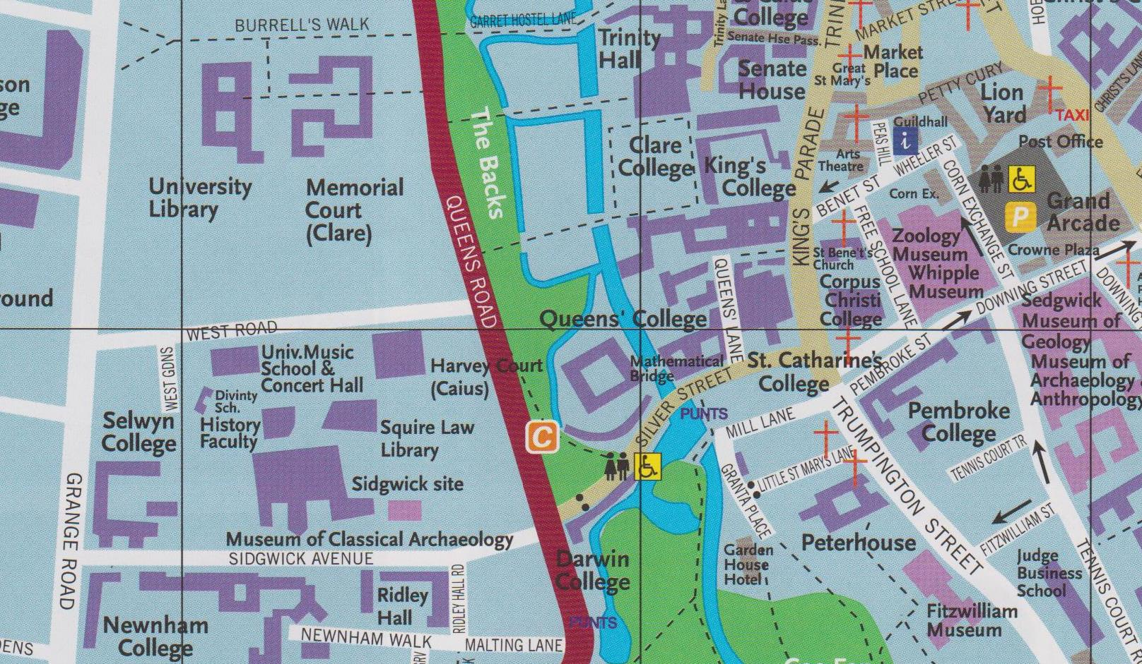
Alumni Dinner Conference Dinner

Please note that there is limited Pay & Display parking in West Road and Sidgwick Avenue but no parking on the Sidgwick Site.
There is a Park & Ride Site in Madingley Road and the Uni4 bus stops in West Road.

